LA FÊTE DE L’AUTOMNE
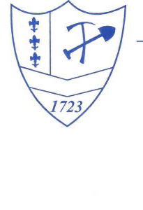
SUNDAY OCTOBRE 2, 2022
11:00 a.m. 4:00 p.m.
Flag Raising 11:00 a.m.

299 ANS DES FRANCAIS DANS LE COMTÉ WASHINGTON
299 YEARS OF THE FRENCH IN WASHINGTON COUNTY
1723 – 2022

HONORED FAMILY – JULIETTE

COUNTRY STORE ICE CREAM
1800’S CRAFTS STORY TELLING
APPLE BUTTER MAKING LA BOULANGERIE (THE BAKERY)
17th TO 21st CENTURY GENEALOGY and PUBLICATIONS
LOG HOME MUSEUM
LES CROQUIGNOLES (A FRENCH PASTRY)
FRENCH SAUSAGES HAM & BEANS ROASTED CORN ON COB

French Creole Music by the internationally known
Dennis Stroughmatt et L’esprit Creole

OLD MINES AREA HISTORICAL SOCIETY

Check additional information at www. omahs .weebly.com
The Fete Location is The Archive Building Grounds At The Junction Of Highways 21 And CC

DIRECTIONS – SOUTH FROM ST. LOUIS – FROM HWY 21 PASS WASHINGTON STATE PARK NORTH ENTRANCE TO HWY CC – TURN LEFT
NORTH FROM POTOSI – FROM HWY 21 PASS WASHINGTON STATE PARK SOUTH ENTRANCE TO HWY CC – TURN RIGHT

POUR PLUS D’INFORMATION FOR MORE INFORMATION
OLD MINES INFORMATION – 573-436-9140
HANDICAP ACCESS – SHUTTLE AVAILABLE
FREE ADMISSION – FREE PARKING – BRING YOUR OWN LAWN CHAIRS
REMEMBER TO WEAR WALKING SHOES – THE FETE GROUNDS ARE ROCKY AND UNLEVEL

